# UAT Test – Bug 2 Report – assignment 4

## by Abhimanyu Bhat - 11732514

### Bug 2 – Incorrect fine amount LEVIED: -

|  |  |  |  |  |  |  |
| --- | --- | --- | --- | --- | --- | --- |
| **Test #** | **Description of tasks** | **Steps to execute** | **Expected results** | **Pass** | **Fail** | **Comments** |
| 1 | Checking whether the fines imposed 2 days after a due date are accurate. The task has been done for 4 days and 5 days as well. | 1. Add patrons to the database | Patron is created | Yes |  |  |
|  |  | 2. Add books to the database (name, title, etc.) | Book entry is created | Yes |  |  |
|  |  | 3. Take out a loan for a book | Book loan is taken out | Yes |  |  |
|  |  | 4. Increment date to a date two days past due date using T | Date is incremented two days past due date | Yes |  |  |
|  |  | 5. Return the book two days after due date | Fine should be double since it is two days past due date. |  | Yes | No double fine imposed despite being Overdue for 2 days. |

#### Screenshot of borrowing and returning books two days later:

The overdue fine is $1.00 but it should be $2.00 because the number of days exceeding is 2

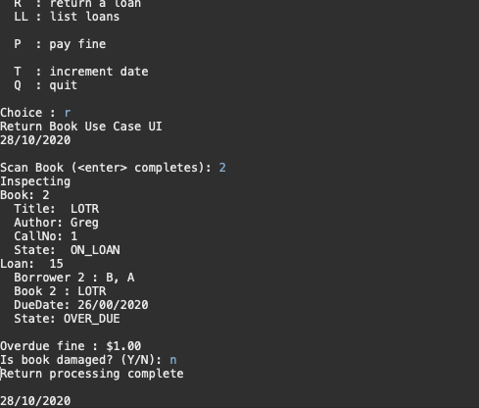

#### Screenshot of borrowing and returning books four days later:

The overdue fine is $2.00 but it should be $4.00 because the number of days exceeding is 4

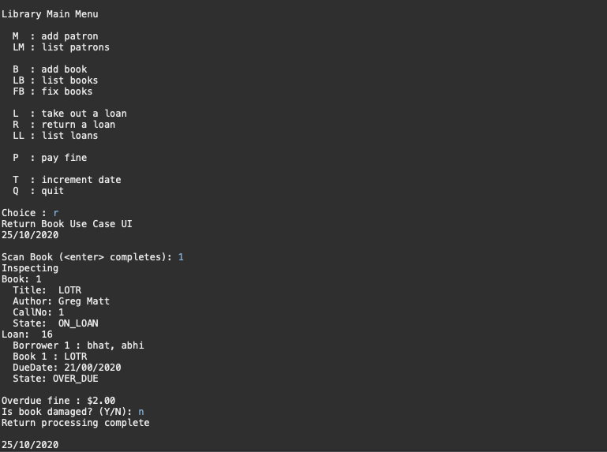

#### Screenshot of borrowing and returning books five days later:

The overdue fine is $2.00 but it should be $5.00 because the number of days exceeding is 5

